1. Anomalous temperature and chronic disease mortality in the United States

Overview
[[[WORDS]]]

Introduction
- Deaths from cardiorespiratory disease have been associated with temperature
- However, hitherto no analysis by type of cardiorespiratory disease, by age group, sex

- No cancer association normally

Data

Death rates
I used vital registration data on all injury deaths in the contiguous United States from 1980 to 2016, with information on sex, age at death, underlying cause of death and state of residence. Full details of the method I developed to generate the data can be found in Chapter XX.

Cardiorespiratory deaths
During 1980-2016, XX boys and men and XX girls and women died from an injury in the contiguous United States (i.e., excluding Alaska and Hawaii), accounting for XX% and XX% of all male and female deaths respectively. XX% of male XX deaths and XX% of female XX deaths were in those aged XX years and older, and over XX (XX%) of male XX deaths were in those aged XX-XX years (Figure 1). In XX with males, there was more/less of an age gradient in females after XX years of age.
Injuries from transport, falls, drownings, assault, and suicide accounted for 79.0% of injury deaths in males and 72.1% in females. The remainder were from a heterogeneous group of “other unintentional injuries” (Figure 1), within which the type of injury that led to death varied by sex and age group. Transport was the leading injury cause of death in women younger than 75 years and men younger than 35 years. Between 35 and 74 years of age, more men died of suicide than any other injury. Above 75 years of age, falls were the largest cause of death in both men and women.
There was a decline in age-standardised death rates of three out of five major injuries (transport, drownings and assault) from 1980 to 2016, although assault deaths have shown a recent increase since 2014 (Figure 2). In contrast, age-standardised death rates from falls increased over time while those from suicide initially decreased followed by an increase to surpass 1980 levels. The largest overall decline over time was for transport deaths, which declined by over 50% from 1980 to 2016. Age-standardised death rates for transport injuries and drownings peaked in summer months but deaths from other major injuries did not have clear seasonal patterns.

Cancer and other deaths
[[[WORDS]]]

Anomalous temperature
I obtained data on temperature from ERA-Interim, which combines predictions from a physical model with in-situ and satellite measurements (Dee et al., 2011). I used gridded four-times-daily estimates at a resolution of 80 km to generate monthly population-weighted temperature by state throughout the analysis period. Full details of the method I developed to generate the data can be found in Chapter XX.

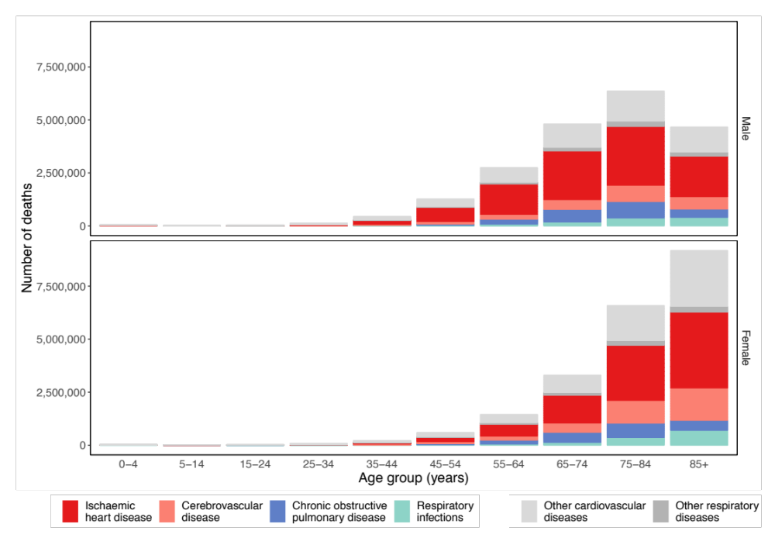
Figure 1. Number of cardiorespiratory deaths deaths, by type of cardiovascular (ischaemic heart disease and cerebrovascular disease) and (COPD and respiratory infections) disease, by sex and age group in the contiguous United States for 1980-2016.
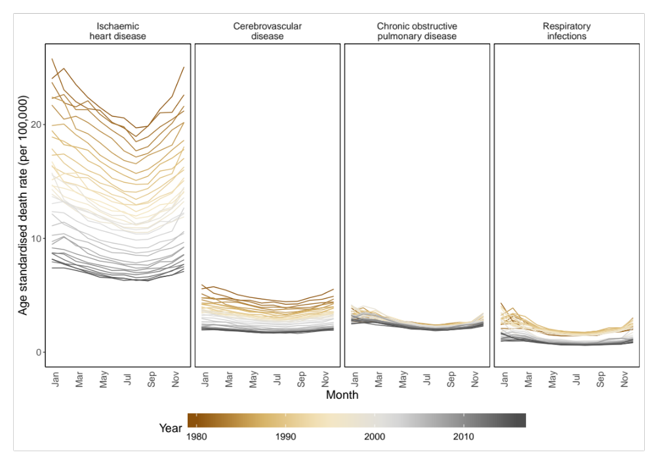
Figure 2. National male age-standardised death rates from 1980 to 2016, by cardiorespiratory disease and month
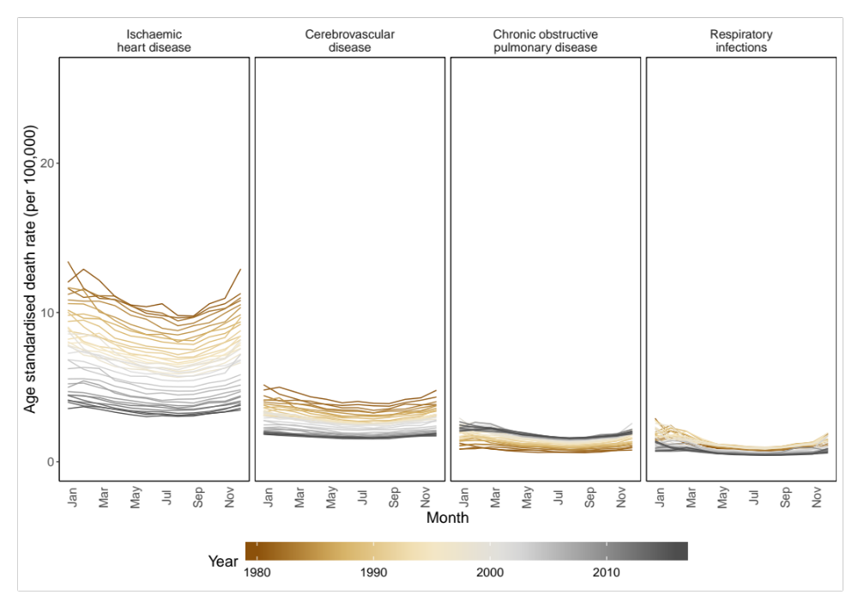
Figure 3. National female age-standardised death rates from 1980 to 2016, by cardiorespiratory disease and month
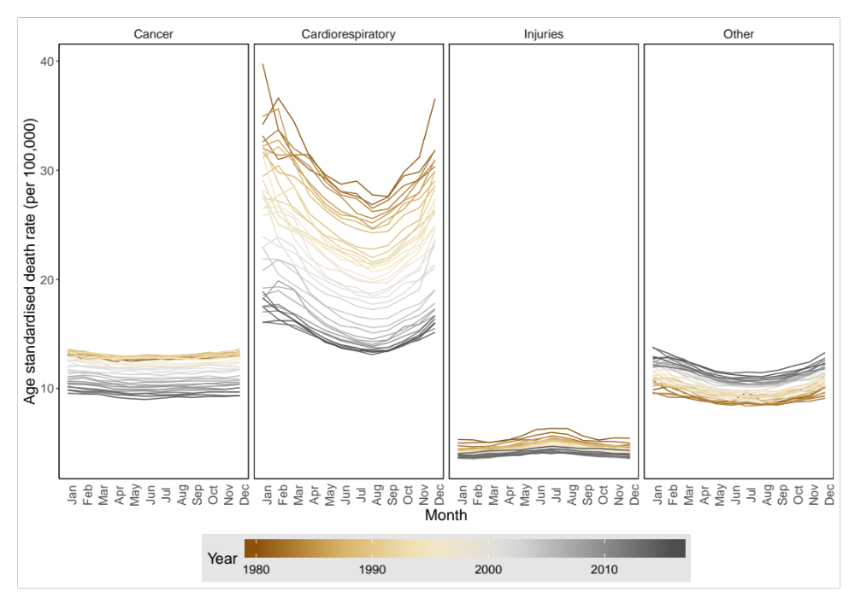
Figure 3. National female age-standardised death rates from 1980 to 2016, by cardiorespiratory disease and month

Statistical methods

National temperature model
I then analysed the association of monthly cardiorespiratory death rates with anomalous temperature using a Bayesian spatio-temporal model, described in Chapter XX. The model accounted for systematic variations in death rates across states and months, through state-, month- and state-month-specific random intercepts, and for their long-term trends. These terms together remove the effects of space and time varying factors other than temperature that affect injuries. Analyses were done separately by injury type, sex and age group. I used the resultant risk estimates and the age-sex-specific death rates from each injury in 2016, to calculate additional deaths if each month in each state were +1°C above its long-term norm, by type of injury, sex, age group, state and month.

Subnational temperature model
I also attempted to run a model where each state was given a separate temperature anomaly coefficient (Equation XX in Chapter XX). However, the model would either not converge or not achieve sensible results without combining all cardiorespiratory diseases together. In Results, I present some results from this analysis.

Results

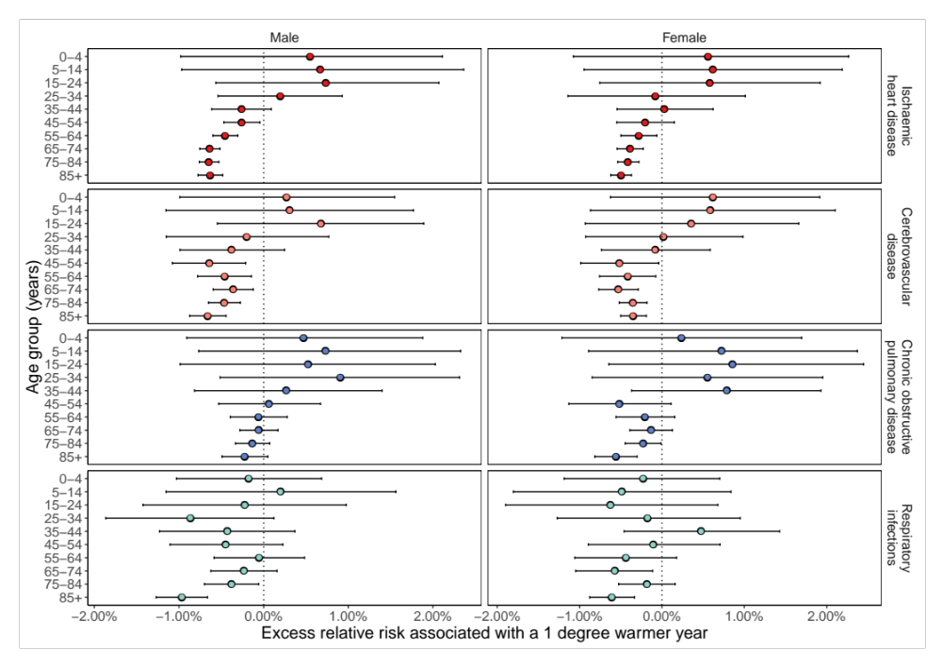
Figure 4. Percent change in death rates in year in which each month was +1°C compared with 1980-2009 norm temperatures by cardiorespiratory disease, sex and age group summarised across months.

Figure 5. Percent change in death rates in year in which each month was +1°C compared with 1980-2009 norm temperatures by cardiorespiratory disease, sex and month summarised across age.
Figure 5. Percent change in cancer death rates in year in which each month was +1°C compared with 1980-2009 norm temperatures by sex and month summarised across age.

Figure 6. Additional annual cardiorespiratory disease deaths for the 2016 US population in year in which each month was +1°C compared with 1980-2009 norm temperatures. The top row shows breakdown by type of injury, sex and age group. The bottom row shows the break down by cardiorespiratory disease, sex and month. Black dots represent net changes in deaths for each set of bars.

Discussion
[[[Words]]]

Figure 6. Percent change in ischaemic heart disease death rates in year in which each month was +1°C compared with 1980-2009 norm temperatures by month, sex and age group.

Figure 7. Percent change in cerebrovascular disease death rates in year in which each month was +1°C compared with 1980-2009 norm temperatures by month, sex and age group.

Figure 8. Percent change in COPD death rates in year in which each month was +1°C compared with 1980-2009 norm temperatures by month, sex and age group.
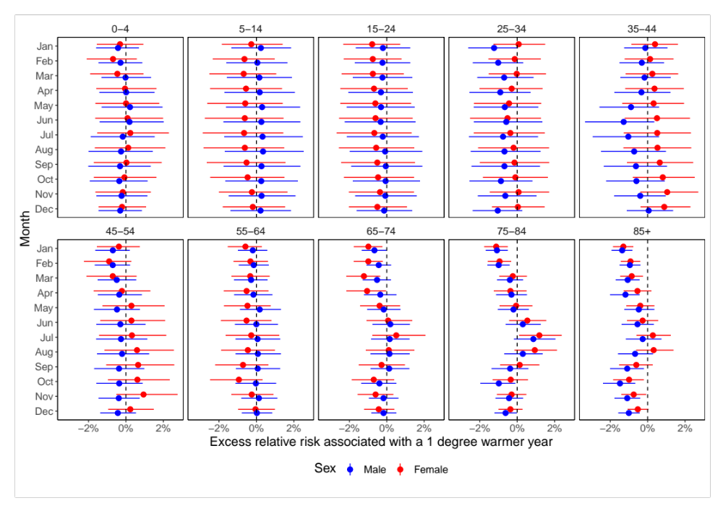
Figure 9. Percent change in respiratory infection death rates in year in which each month was +1°C compared with 1980-2009 norm temperatures by month, sex and age group.

Figure 10. Percent change in other cardiovascular disease death rates in year in which each month was +1°C compared with 1980-2009 norm temperatures by month, sex and age group.

Figure 11. Percent change in other respiratory disease death rates in year in which each month was +1°C compared with 1980-2009 norm temperatures by month, sex and age group.

Figure 11. Percent change in cancer death rates in year in which each month was +1°C compared with 1980-2009 norm temperatures by month, sex and age group.

Figure 11. Percent change in OTHER death rates in year in which each month was +1°C compared with 1980-2009 norm temperatures by month, sex and age group.

Works cited
Dee, D. P., Uppala, S. M., Simmons, A. J., Berrisford, P., Poli, P., Kobayashi, S., … Vitart, F. (2011). The ERA-Interim reanalysis: configuration and performance of the data assimilation system. Quarterly Journal of the Royal Meteorological Society, 137(656), 553–597. https://doi.org/10.1002/qj.828

